State educational institution

"Children's health camp" Suzorie"

HUMANITARIAN PROJECT

"SPORTS AND ENTERTAINMENT ZONE -

THE KEY TO THE RIGHT HABITS "

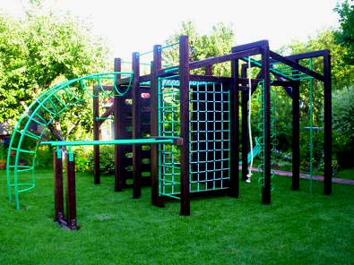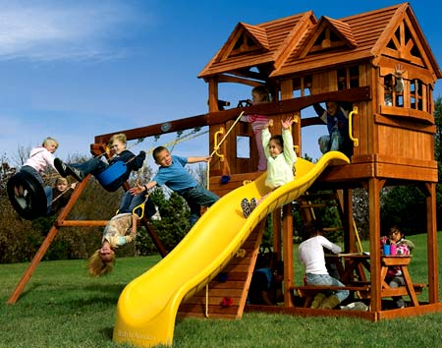

|  |  |
| --- | --- |
| Name of the project: | "Sports and entertainment zone -  the key to the right habits " |
| Implementation period: | 1 year from the start of the project |
| Applicant organization proposing the project: | State educational institution "Children's health camp" Suzorie ", place Porechye, Grodno region |
| Objective of the project: | 1. Creation of a sports and entertainment zone to attract the pupils of the Children's Health Camp "Suzorie" in the summer health period;  2. Attracting schoolchildren, youth and residents of the Grodno region to conducting weekend tours.  3. Increasing the interest of residents of the Grodno region to a healthy lifestyle. |
| Tasks planned within the project: | 1. - popularization of a healthy lifestyle among children and their parents, residents of the Grodno region and involving them in physical education and sports; 2. - Creation of free opportunities for residents of the Grodno region to engage in physical education and sports, spend time with their families; 3. - Holding mass events: "Weekend Tour", New Year, Christmas, Maslenitsa. |
| Target group: | Children and adolescents  Parents of pupils  Youth and students  Large families  Persons with disabilities |
| Brief description of project activities: | The project "Sports and entertainment ground - the key to the right habits" is aimed at the massive involvement of children, youth and people of the older generation to physical education, to maintain a healthy lifestyle. The project is to create on the territory of the state educational institution "Children's Health Camp" Suzore "a sports and entertainment zone for the recreation of pupils, and in the off-season - holding sports events and holidays in a picturesque place on the shore of Lake" Molochnoe". The implementation of the project "Sports and entertainment zone - the key to the right habits" will allow to organize the leisure of children and adults, to exclude lack of physical activity, will unite adults and children. |
| Total funding  (in USD)  co-financing | 22 500  2 500 |
| Place of implementation: | State educational institution "Children's health camp" Suzorie " |
| The contact person: | Kivlyak Alla Vikentievna, Head of the State Public Organization "Children's Health Camp" Suzorie ", tel.  **8-0152-41 60 75**, +375333115761, suzore@yandex.by  We look forward to cooperation! |