State educational institution

"Children's health camp" Suzorie"

HUMANITARIAN PROJECT

"ARRANGEMENT OF THE PIRER AND BEACH AREA -

KEY TO CHILDREN'S SAFETY AND EXCELLENT HEALTH"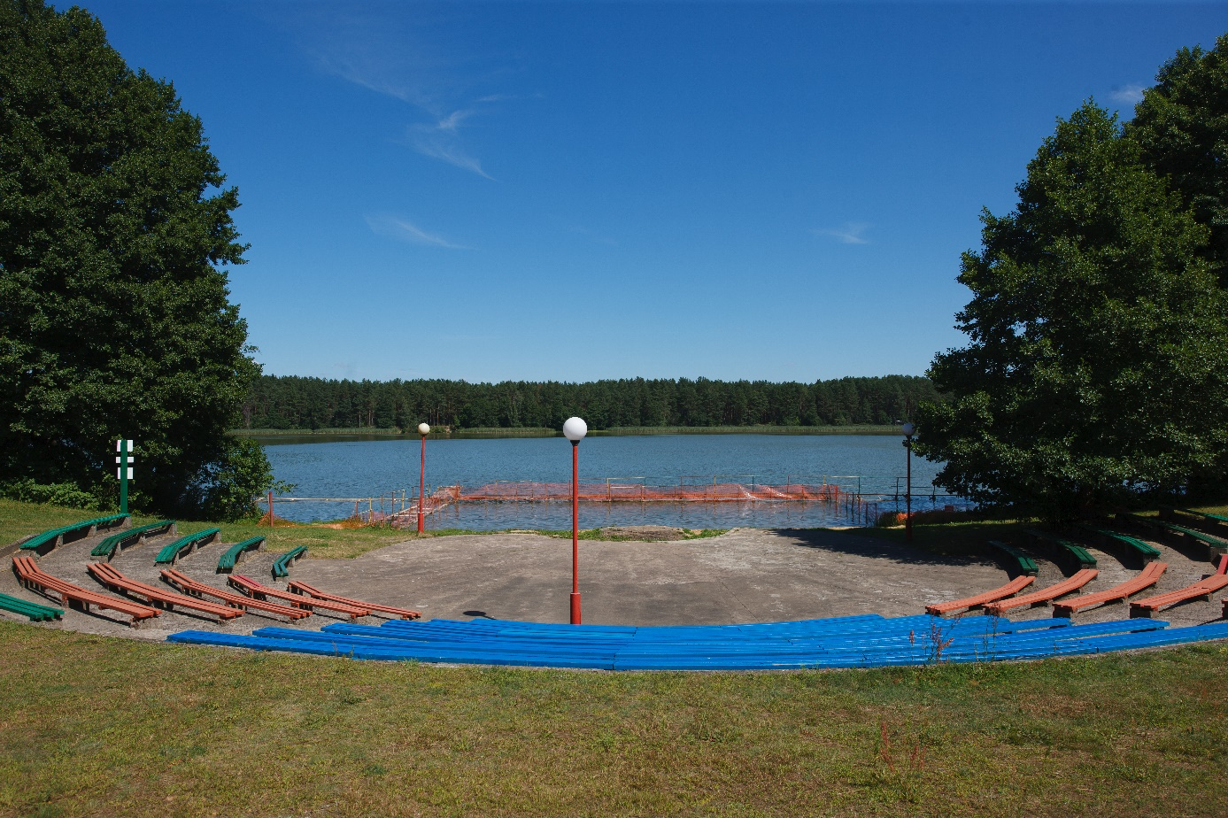

|  |  |
| --- | --- |
| Name of the project: | "Arrangement of the pier and the beach area - key to children's safety and excellent health" |
| Implementation period: | 1 year from the start of the project |
| Applicant organization proposing the project: | State educational institution "Children's health camp" Suzorie ", place Porechye, Grodno region |
| Objective of the project: | 1. Arrangement of a pier on Molochnoe Lake, located on the territory of the state educational institution "Children's Health Camp" Suzorie "to ensure the bathing of children in the summer health period.  2. Increasing the interest of pupils in a healthy lifestyle. |
| Tasks planned within the project: | 1. - To organize bathing of schoolchildren in the summer health-improving period, which fully contributes to the education of collectivism, mutual assistance; 2. - popularization of a healthy lifestyle among children; 3. -Сold acclimation schoolchildren in the summer health period; 4. -Distraction of adolescents from long-term communication with phones and other gadgets, involvement in "live" communication with peers. |
| Target group: | Children and adolescents, including those with disabilities, are recuperating in the state educational institution "Children's Health Camp" Suzorie ".  Parents of students  Youth and students |
| Brief description of project activities: | The problem of preserving the health of the population and introducing children to a healthy lifestyle is of social importance. The project "Arrangement of the pier and the beach area - key to children's safety and excellent health" is aimed at the massive involvement of children and youth in physical education, and a healthy lifestyle. The project consists in arranging a pier on Lake Molochnoe, located on the territory of the state educational institution "Children's Health Camp" Suzorie ".  Implementation of the project “Arrangement of the pier and the beach area - key to children's safety and excellent health. |
| Total funding  (in USD)  co-financing | 50 000  2 500 |
| Place of implementation: | State educational institution "Children's health camp" Suzorie " |
| The contact person: | Kivlyak Alla Vikentievna, Head of the State Public Organization "Children's Health Camp" Suzorie ", tel.  **8-0152-41 60 75**, +375333115761, suzore@yandex.by  We look forward to cooperation! |